Exercise

- Explain OOPS concept with an example.
Answer:
Inheritance:
It lets subclass inherit characteristics of the parent class. Parent class decides what and how its properties/methods to be inherited by declared visibility.
class Shape {
public function name() {
echo "I am a shape";
}
}
class Circle extends Shape {
}
$circle = new Circle();
$circle->name();
Polymorphism:
The provision of a single interface to entities of different types. Basically it means PHP is able to process objects differently depending on their data type or class. This powerful feature allows you to write interchangeable objects that sharing the same interface.
interface Shape {
public function name();
}
class Circle implements Shape {
public function name() {
echo "I am a circle";
}
}
class Triangle implements Shape {
public function name() {
echo "I am a triangle";
}
}
function test(Shape $shape) {
$shape->name();
}
test(new Circle());
test(new Triangle());
Encapsulation:
Encapsulation is used to hide the values or state of a structured data object inside a class, preventing unauthorized parties' direct access to them. It is a concept that motivates us to think through a method/class responsibility and hide its internal implementation/details accordingly. This will make it easy to modify the internal code in a long run without affecting other part of the system. Visibility is the mechanism for encapsulation.
class Person {
private $name;
public function setName($name) {
$this->name = $name;
}
public function getName($name) {
return $this->name;
}
}
$obj = new Person();
$obj->setName(‘Abc’);
$obj->getName();

Abstraction:
Abstraction is the concept of moving the focus from the details and concrete implementation of things, to the types of things (i.e. classes), the operations available (i.e. methods), etc, thus making the programming simpler, more general, and more abstract. It is like a generalization instead of a specification.
class TV {
private $isOn = false;
public function turnOn() {
$this->isOn = true;
}
public function turnOff() {
$this->isOn = false;
}
}
$tv = new TV();
$tv->turnOn();
$tv->turnOff();
- Explain Classes & Objects with an example.
Answer :
Class: This is a programmer defined data type, which includes local functions as well as data. Aclass is a template for making many instances of the same kind of object.
Object: An individual instance of the data structure defined by a class. We define a class once and then make many objects that belong to it. Objects are also known as instance.
We can create as many objects from a class as we like. An example in layman terms would be:
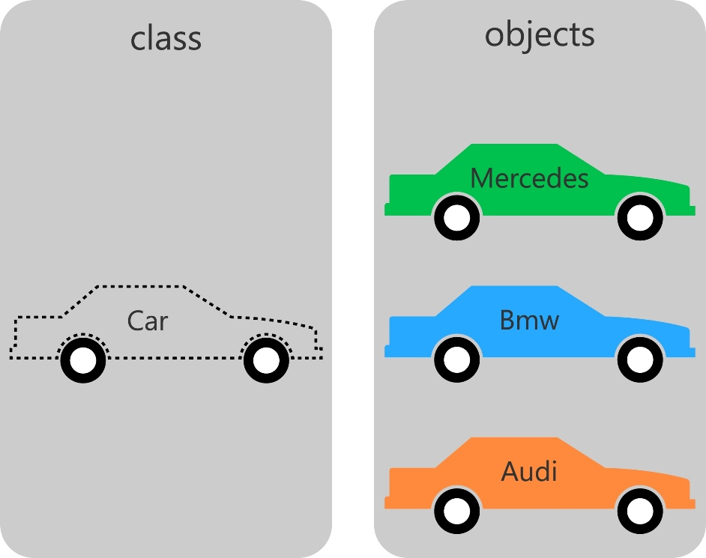 From the same Car class, we created three individual objects with the name of: Mercedes, Bmw, and Audi.
Although all of the objects were created from the same class and thus have the class's methods and properties, they are still different. This is not only, because they have different names, but also because they may have different values assigned to their properties.

Example:
Class Car{
public function something(){
echo”I am a car”;
}
}
$obj=new Shape();
$obj->something();

- What is a Namespace?
Answer : In the broadest definition namespaces are a way of encapsulating items. In the PHP world, namespaces are designed to solve two problems that authors of libraries and applications encounter when creating re-usable code elements such as classes or functions:
- Name collisions between code you create, and internal PHP classes/functions/constants or third-party classes/functions/constants.
- Ability to alias (or shorten) Extra_Long_Names designed to alleviate the first problem, improving readability of source code.
We can declare the same function, class, interface and constant definitions in separate namespaces without receiving fatal errors. Essentialy, a namespace is nothing more than a hierarchically labeled code block holding regular PHP code.
Example:
<?php
namespace MyProject {
// Regular PHP code goes here.
function run(){
echo 'Running from a namespace!';
}
}

- Explain constructor and destructor with an example.
Answer : PHP 5 allows developers to declare constructor methods for classes. Classes which have a constructor method call this method on each newly-created object, so it is suitable for any initialization that the object may need before it is used.
When we create a new object, it is useful to initialize its properties. PHP provides us with a special method to help initialize object’s properties called constructor.
Constructors can accept parameters, that are assigned to specific object fields at creation time.
- Constructors can call class methods or other functions.
- Class constructors can call on other constructors, including those from the pare
Example:
<?php
class A{
function A(){
echo ’User defined function’;
}
function __construct(){
echo ‘Predefind function’;
}}
$obj=new A();
}
Destructor: The destructor is another feature of "OOP". The destructor concept was introduced in PHP5 and it is conceptually similar to that of other object oriented languages. The destructor method will be called as soon as there are no other references to a particular object or when the object has been explicitly destroyed.
Example:
<?php
class MyClass
{
function __construct(){
print "In constructor";
$this->name = "MyClass obj explicity";
}
function __destruct(){
print "Destroying " . $this->name . "\n";
}}
$obj = new Myclass();
?>

- Write a program that initialize class property using constructor.
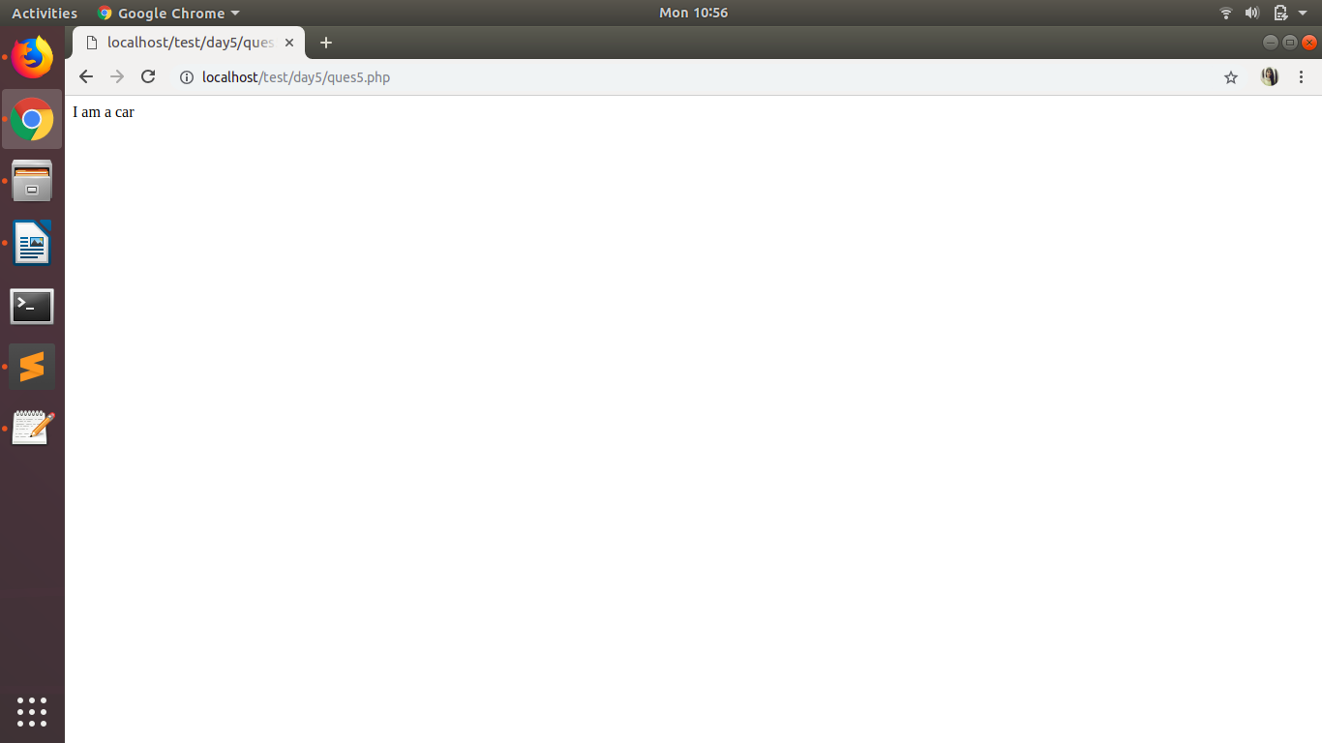
Answer :

- Write a PHP program to return Factorial value of number in a Object oriented way. Factorial logic should be in separate function.
Answer :
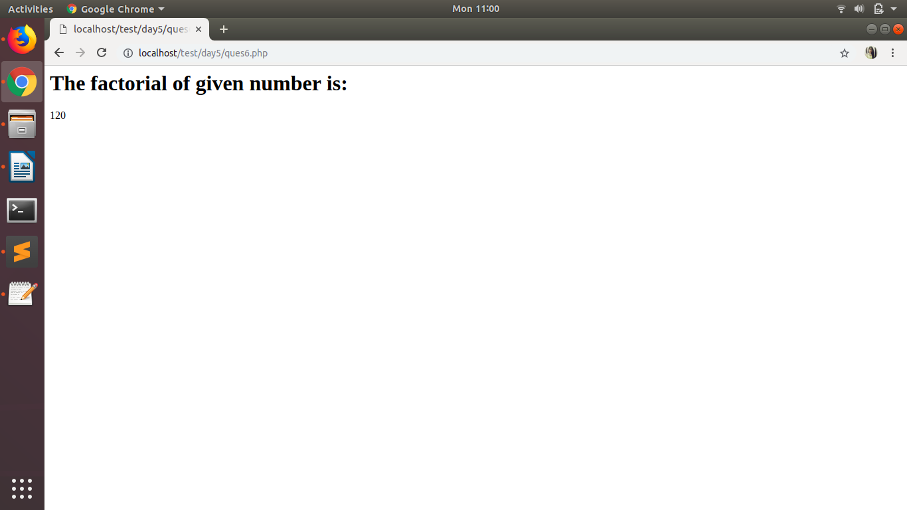

- Write a class that extends Abstract class.
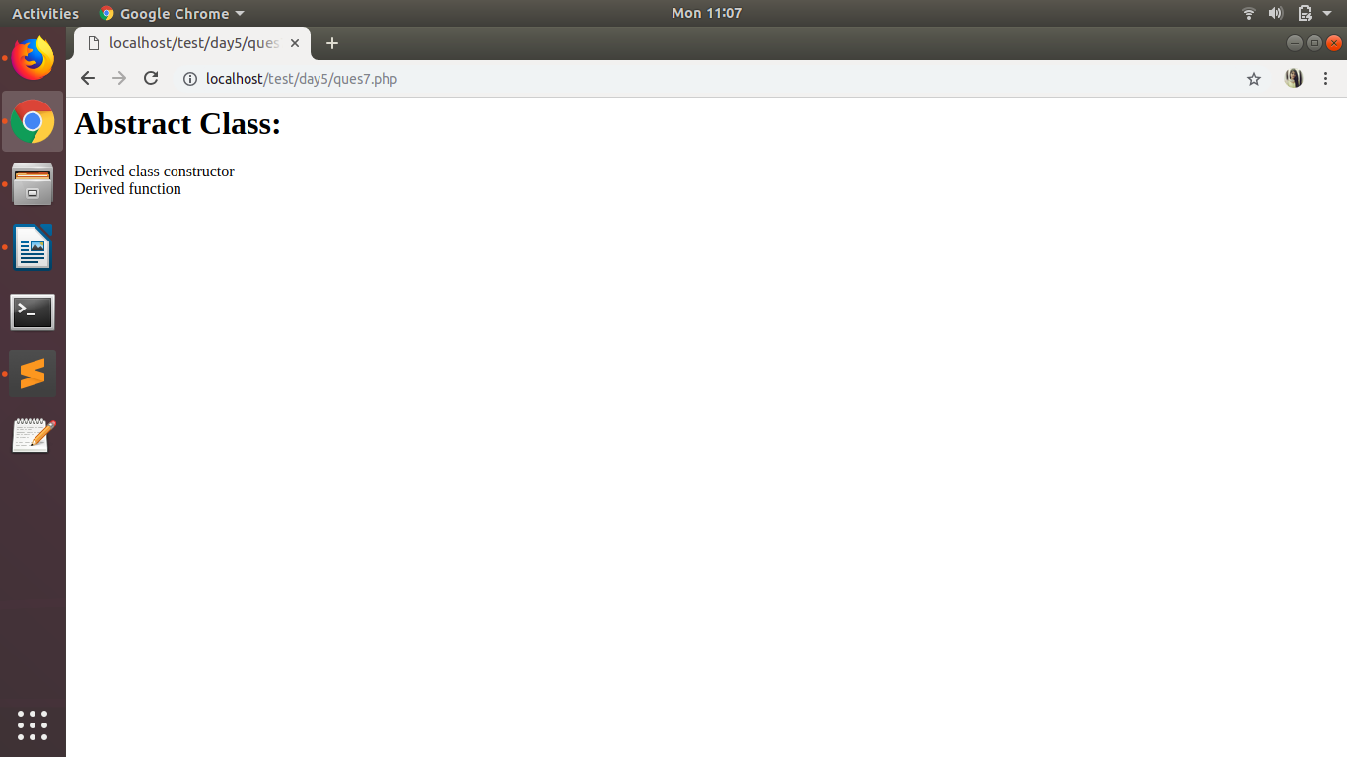
Answer :

- Implement Inheritance in PHP program to display the Message when Parent class method is called and when the Child method is called.
Answer :
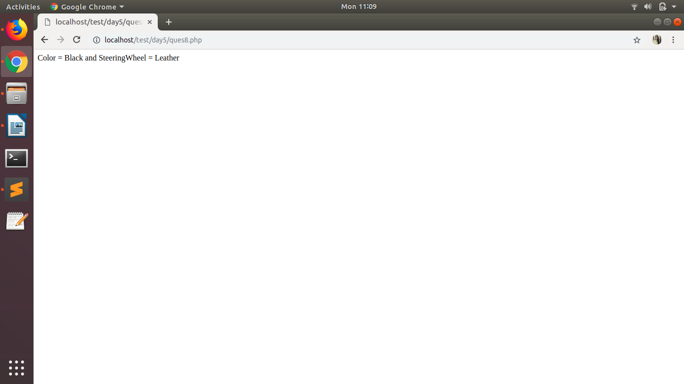

- What is method chaining explain with an example.
Answer :When many methods are called in a single instruction, in PHP’s term it is called Method
Chaining.
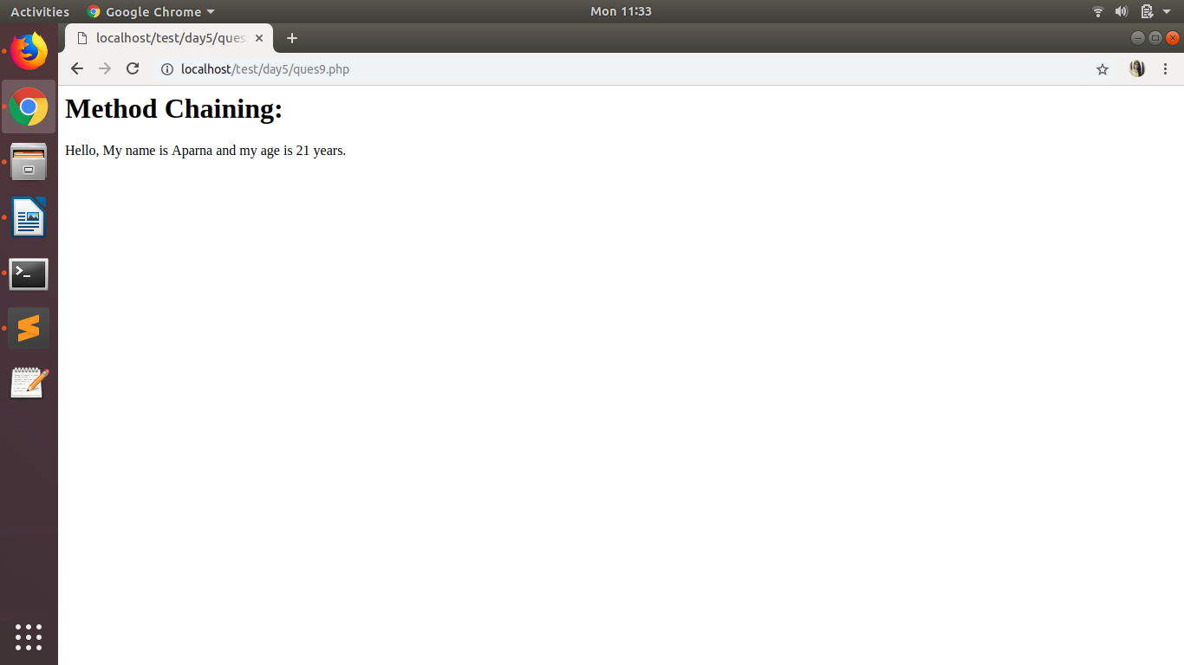

- What is $this keyword.
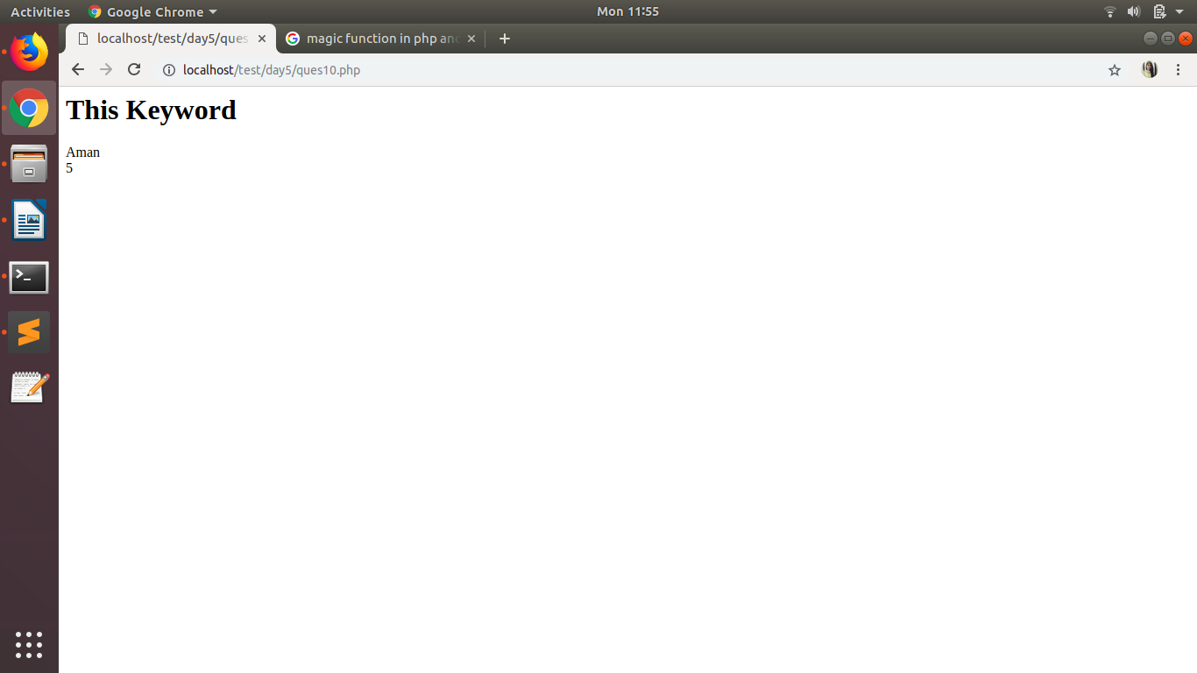
Answer : The $this is a keyword which represents the current object or current instance of class.$this is a special self-referencing variable that is used to access properties and methods from within the class.
- Write program to explain Multi Level Inheritance.
Answer :
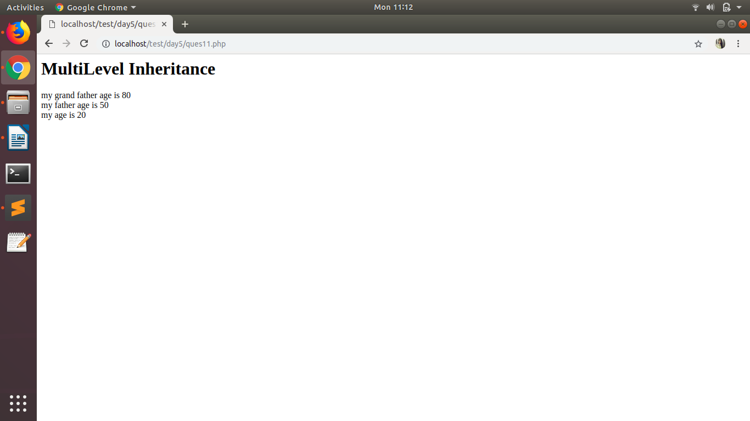
- What is magic method. Explain these method __call(), __isset(), __unset(), __sleep(), __wakeup() with example.
Answer : Magic methods in php are some predefined function by php compiler which executes on
some event. Magic methods starts with prefix __,PHP reserves all function names starting with __ as magical. It is recommended that we do not use function names with __ in PHP unless you want some documented magic functionality.
The function names __construct(), __destruct(), __call(), __callStatic(), __get(), __set(), __isset(), __unset(), __sleep(), __wakeup(), __toString(), __invoke(), __set_state(), __clone() and __debugInfo() are magical in PHP classes. You cannot have functions with these names in any of your classes unless you want the magic functionality associated with them.

All magic functions must be declared as public.

